|  |  |  |
| --- | --- | --- |
| **Lyng Primary School P.E Knowledge Organiser** | | |
| **Topic: GYMNASTICS** | Year 3 | Spring 1 |





**Enquiry Questions**

* How can we ensure we jump as high as possible?
* How can we perform different point balances at height?
* How do we perform a dish roll?
* Can we perform a sequence individually and as a group?
* How can we ensure we land safely when jumping and landing from height?
* How can we mount and dismount a vault safely?

|  |  |
| --- | --- |
| **Key words** | |
| **Spelling** | **Definition** |
| Dish roll | Straight arms & legs slightly raised of the floor and rotating to your body and rolling across the mat. |
| Group Balance | A group balance is a group that are all connected and performing a balance together as one. |
| Half turn jump | When facing one way, completing a jump by turning 180 degrees and landing facing the opposite way you started. |
| Landing | When returning to the ground safely, landing on your feet. |
| Pose | Performing a shape/letter before completing a roll, jump or balance. |
| Sequence | Being able to link everything learnt and perform a sequence to the group. |

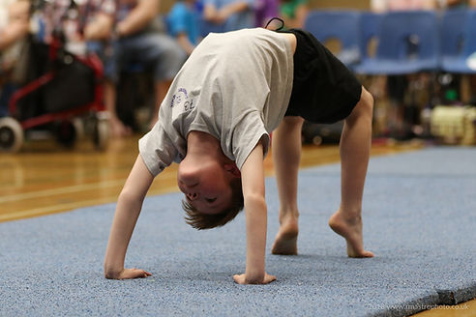

***“See, Believe & Achieve”***

**– Mav Levy**

|  |  |  |
| --- | --- | --- |
| **Lyng Primary School P.E Knowledge Organiser** | | |
| **Topic: GYMNASTICS** | Year 3 | Spring 1 |

Learning Outcomes

* To be able perform jumps, stands & positions.
* To be to perform individual and group point balances at height.
* To be able to perform a rolls using equipment.
* To perform a sequence/routine of movements, rolls & balances.
* To be able to land safely when jumping from height
* To be able to perform jumps when using a vault.

